# DS 1108 -Web Programming I

# Practical Day 01

The three main languages we use to build websites are HTML, CSS and JavaScript.

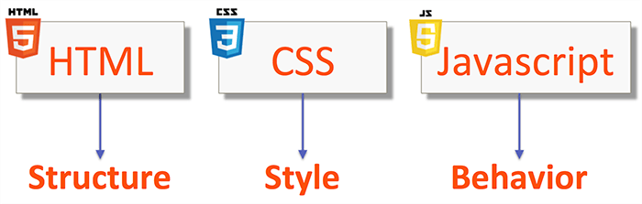

**Introduction To HTML**

1. 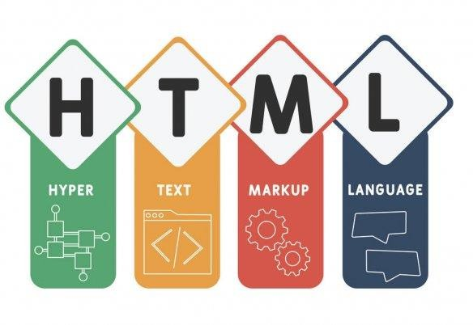What is HTML?

HTML is an acronym which stands for **Hyper Text Markup Language** which is used for creating web pages and web applications. Let's see what is meant by Hypertext Markup Language, and Web page.

Hyper Text:

* + HyperText simply means "Text within Text."
  + A text has a link within it, is a hypertext.
  + Whenever you click on a link which brings you to a new webpage, you have clicked on a hypertext.
  + HyperText is a way to link two or more web pages (HTML documents) with each other.

Markup language:

* + A markup language is a computer language that is used to apply layout and formatting conventions to a text document.
  + Markup language makes text more interactive and dynamic. It can turn text into images, tables, links, etc.

Web Page:

* + A web page is a document which is commonly written in HTML and translated by a web browser.
  + A web page can be identified by entering an URL. A Web page can be of the static or dynamic type. **With the help of HTML only, we can create static web pages**.

Hence, HTML is a markup language which is used for creating attractive web pages with the help of styling, and which looks in a nice format on a web browser. An HTML document is made of many HTML tags and each HTML tag contains different content.

1. HTML Page Structure and Sample Code Explanation

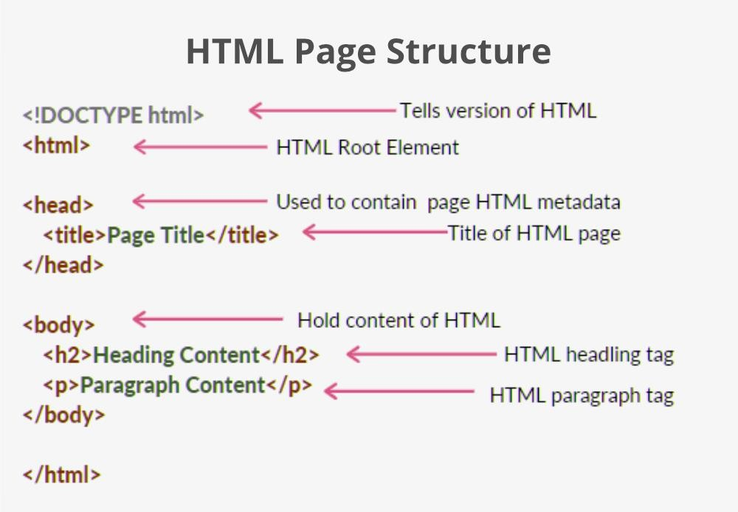

Description of HTML Example :

An HTML (Hypertext Markup Language) page consists of several elements that work together to create the structure and content of a web page. The basic structure of an HTML page includes:

**Document type declaration (DTD):** This is the first line of an HTML document and it specifies which version of HTML the page is written in.

**HTML element:** The HTML element is the root element of an HTML document. It contains all other elements and is usually the first element in the document after the DTD.

**Head element:** The head element contains metadata about the HTML document, such as the title of the page, links to stylesheets, and scripts.

**Body element:** The body element contains the visible content of the web page, such as text, images, videos, and other elements.

In this example, the DTD specifies that the document is written in HTML5. The HTML element is the root element of the document, and it contains the head and body elements. The head element contains a title element that specifies the title of the page, and the body element contains a heading element (<h1>) and a paragraph element (<p>).

1. HTML Elements

An HTML file is made of elements.

HTML (Hypertext Markup Language) elements are the building blocks of web pages. They are used to define the structure and content of a web page.

These elements are responsible for creating web pages and define content in that webpage. An element in HTML usually consists of a start tag <tag name>, close tag </tag name> and content inserted between them.

# Technically, an element is a collection of start tag, attributes, end tag, content between them.

|  |  |  |  |  |  |
| --- | --- | --- | --- | --- | --- |
|  | •  • | **<html>** | | | : The root element that encloses the entire HTML document.  : The container for the document's metadata, such as the title and links to |
| **<head>** | | |
| stylesheets and scripts. | | | | |
| •  •  •  •  • | **<body>** | | | : The container for the visible content of the web page. |
| **<div>** | | : A generic container element that can be used to group other elements together. | |
| **<p>** | : A paragraph element that defines a block of text. | | |
| **<img>** | | : An image element that displays an image on the web page. | |
| **<a>** | : An anchor element that creates a hyperlink to another web page or resource. | | |

1. Web Browser

HTML (Hypertext Markup Language) is used to create the structure and content of web pages, but it does not provide a way to interact with web browsers directly. Instead, HTML is used in conjunction with other web technologies, such as Cascading Style Sheets (CSS) and JavaScript, to create interactive and dynamic web pages.

* + Open the HTML file in a web browser. Here are the basic steps to view an HTML page in a web browser:
  + Create an HTML file: Use a text editor or an HTML editor to create an HTML file. Save the file with a .html file extension.
  + Open the HTML file in a web browser: Locate the HTML file on your computer, right-click on it, and select "Open with" from the context menu. Choose a web browser from the list of available programs.

Alternatively, you can open the web browser and use its "File" menu to navigate to the HTML file on your computer and open it.

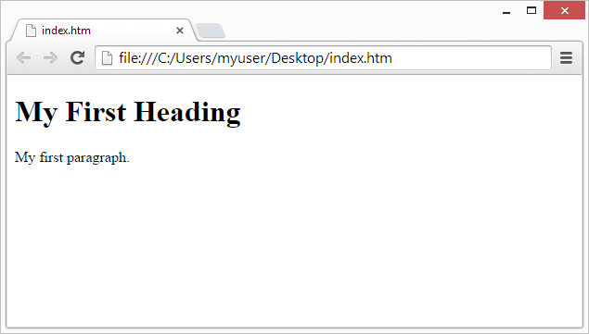View the HTML page: The web browser will display the contents of the HTML file on the screen.

That's it! You can now use the web browser to view any HTML page that you have created or that is available on the web.

Questions

1. HTML stands for?
2. What is a Markup language?
3. Create a basic html web page as below.

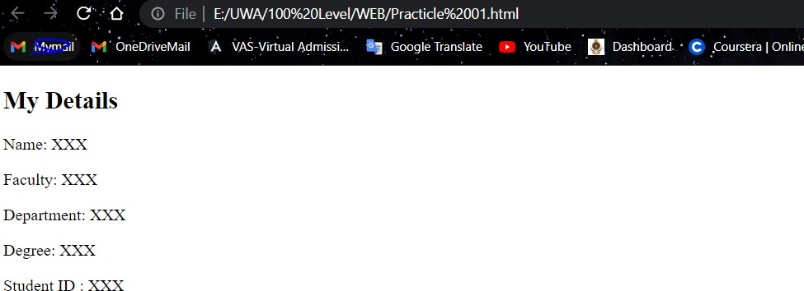

1. Create a basic html web page as below.

1. Which of the following tag is used for inserting the largest heading in HTML?
   1. <h3>
   2. <h1>
   3. <h5>
   4. <h6>